Gender Pay Gap Report
31 March 2023

Nacro is a national charity helping thousands of people every day through our housing, health, justice and education services in England and Wales. We are driven by our values to employ and retain the most talented people to enable the Charity to deliver excellent support to our service users and learners.

We employ more than 250 people and therefore, in accordance with the Gender Pay Gap regulations, Nacro publishes an annual gender pay gap report, showing the difference in average female earnings compared to average male earnings, regardless of their job roles.

Employers are required by the law to report on the following calculations :
- average gender pay gap as a mean average.
- average gender pay gap as a median average.
- proportion of males and females when divided into quartiles ordered from lowest to highest pay.
- average bonus gender pay gap as a mean average.
- average bonus gender pay gap as a median average.
- proportion of males receiving a bonus payment and proportion of females receiving a bonus payment.

Nacro does not pay bonuses to any of our employees, and therefore we only report the first three calculations. The information below is based on pay data held on our payroll system for all employees as of 31 March 2023.

Gender gap for mean hourly rate of pay.

The mean hourly rate is the average hourly rate for all women employed by Nacro compared to the average hourly rate for all men employed by Nacro.

In Nacro, women’s mean hourly rate is 9.24% lower than the mean hourly rate for men.

Gender gap for median hourly rate of pay
The median hourly rate is calculated by arranging the hourly pay rates of all female employees from highest to lowest and taking the hourly rate that is in the middle of the range. This is compared to the median hourly rate for all male employees.

In Nacro the median hourly rate for women is 4.8 % lower than the median hourly rate for men.

The median gender pay gap across the whole economy is 14.9 % (Annual Survey of Hours and Earnings ONS 2022 report). The median gender pay gap in Nacro is less than the national average median gender pay gap.

Gender Profile by Pay Quartiles

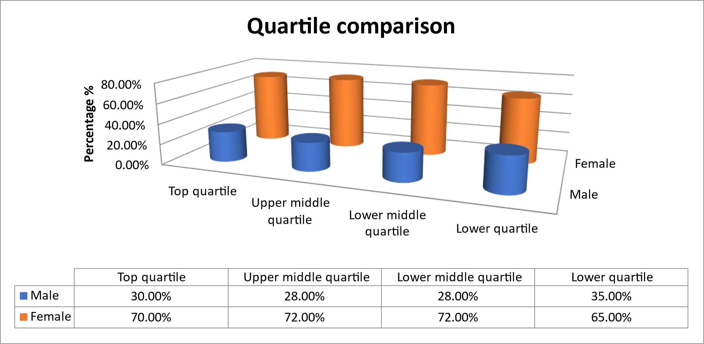

Nacro workforce profile has two features that impact on our overall gender pay gap results.
- Women are over represented in all quartiles.
- Although the proportion of women and men is generally consistent in all quartiles Nacro’s two highest paid roles are occupied by men.

Equality, Diversity & Inclusion
Nacro continues to be committed to promoting equality, diversity, and inclusion in all its activities and at all levels within the Charity. Our Equality, Diversity & Inclusion Manager is leading the delivery of the new strategy for EDI with the support of all our colleagues across Nacro. We are proud that our Executive Team are a balance of 57% women and 43% men, and we will continue to strive to increase diversity within leadership teams across each of our Directorates. Improving our approaches to succession planning and reducing our gender pay gap is important to us. We recognise that we will continue to work hard to reduce the gender pay gap and are focusing on areas of actions as part of our Strategy and People Plan to achieve this ambition.

Recruitment and Selection
To ensure that all our recruitment and selection decisions within Nacro are fair and equitable, we have :
- online and in person training workshops for recruiting managers, which encompasses best practice for equality, inclusion and diversity and managing unconscious bias.
- clear role profiles that are rigorously job evaluated
- a transparent pay and grading system

Our recruitment principals underpin our values with regards to equality and diversity in the workplace as follows:
- We will employ the most suitable person for the job role.
- The recruitment process will be fair and transparent.
- All candidates will be given the opportunity to highlight their capability.
- We will recruit people with a commitment to Nacro’s vision, mission, and values.
- We will recruit people who can and will, or have the potential to, deliver excellent Nacro services for people we support across all our services.

Performance Management
We continue to develop our performance management tools to support all individuals to achieve their potential and aspirations, with a particular focus on individual’s development needs. We use fair and transparent methods to identify those who have the potential to progress and look to provide secondments, mentoring support, and career growth opportunities.

Learning and Development
As part of our mandatory training programme, we ensure that all our employees’ complete diversity, equality, and inclusion training. We also provide learning and development opportunities tailored to roles to build an expert workforce.

Flexible Working
We value our diverse work force and continue to support applications for flexible working requests. We have examples of successful flexible working arrangements across the whole organisation, including a job share of the Housing Director post within our Executive Team.

Our Hybrid Working guidelines support our continuing focus on ensuring that each of our colleagues working for Nacro can work in the right way and in the right place to deliver the best outcomes in their work.

I confirm that the information in this Equal Pay Gap Report is accurate.

Campbell Robb
Chief Executive

